Flipkart Product Recommender Chatbot

1. Project Overview
The Flipkart Product Recommender Chatbot is an AI-powered conversational assistant designed to enhance product discovery using Generative AI and Retrieval-Augmented Generation (RAG).

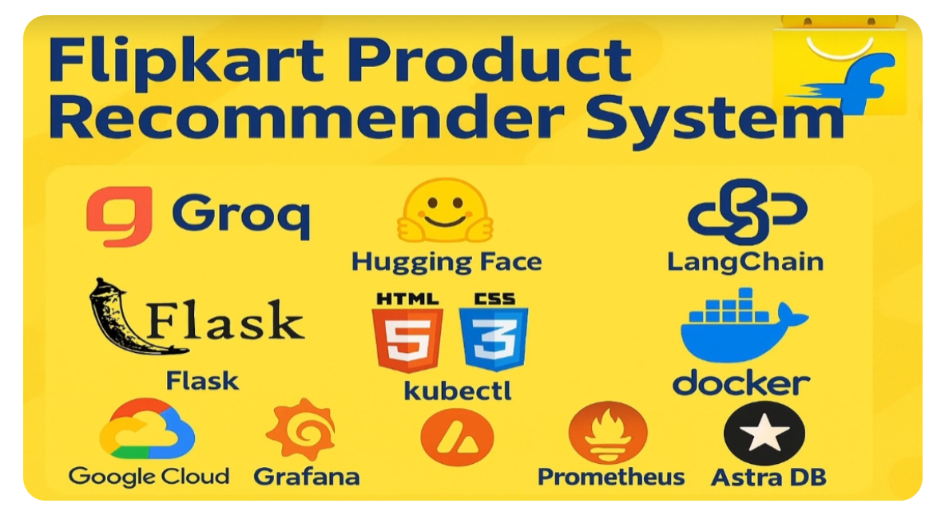

2. Duration
Approximate Time: 3–4 hours (development, deployment, testing).

3. Introduction
This system allows users to interact with an intelligent chatbot to receive personalized product recommendations based on natural language queries.

4. Aim and Objectives
Objectives of the project include:
- Develop a conversational product recommendation system
- Apply RAG in a real-world e-commerce use case
- Enable semantic product search
- Deploy using cloud-native technologies

5. Dataset Used
Dataset: flipkart_product_review.csv
Format: CSV
Description: Contains product names, prices, ratings, and reviews used for semantic search.

6. Tools and Technologies
- Python
- Flask (Backend API)
- Streamlit (UI Prototype)
- Groq LLM
- LangChain & LangGraph
- HuggingFace Embeddings
- AstraDB Vector Database
- Docker & Kubernetes (Minikube)
- Prometheus & Grafana
- GCP cloud

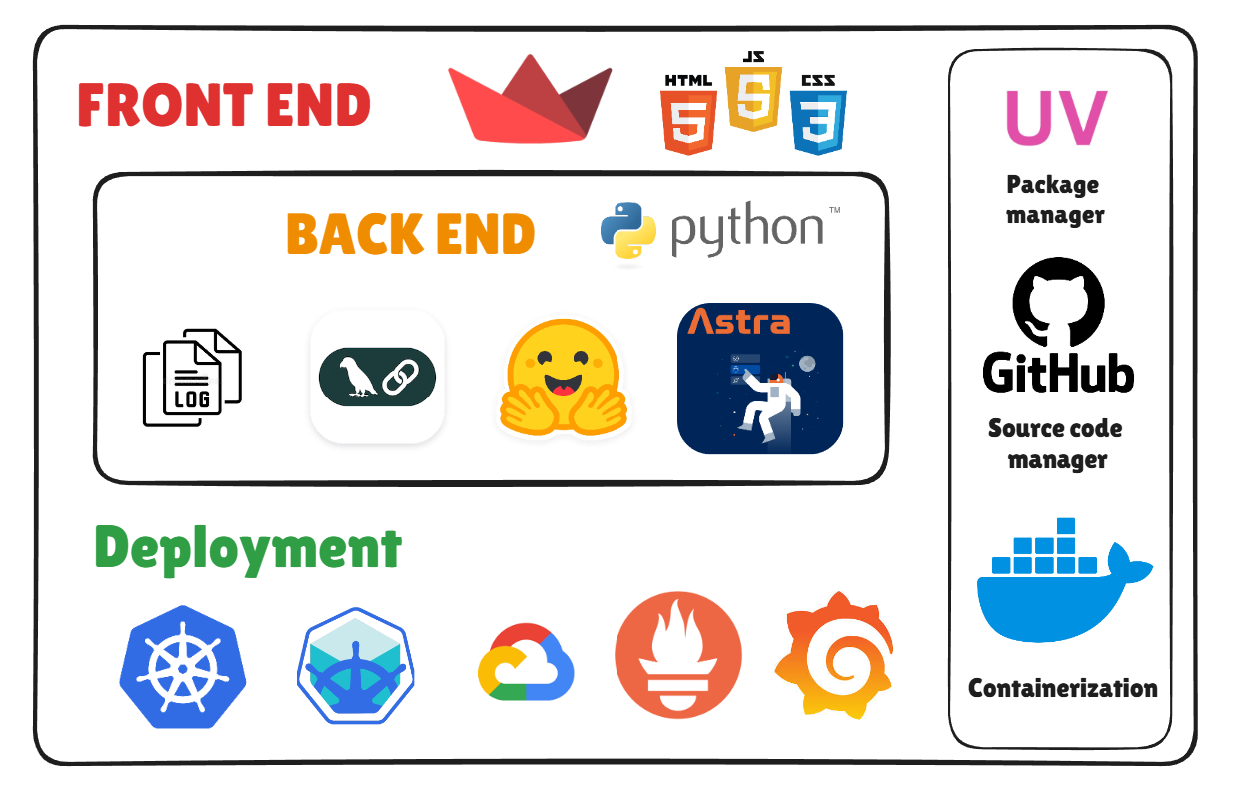

7. Architecture

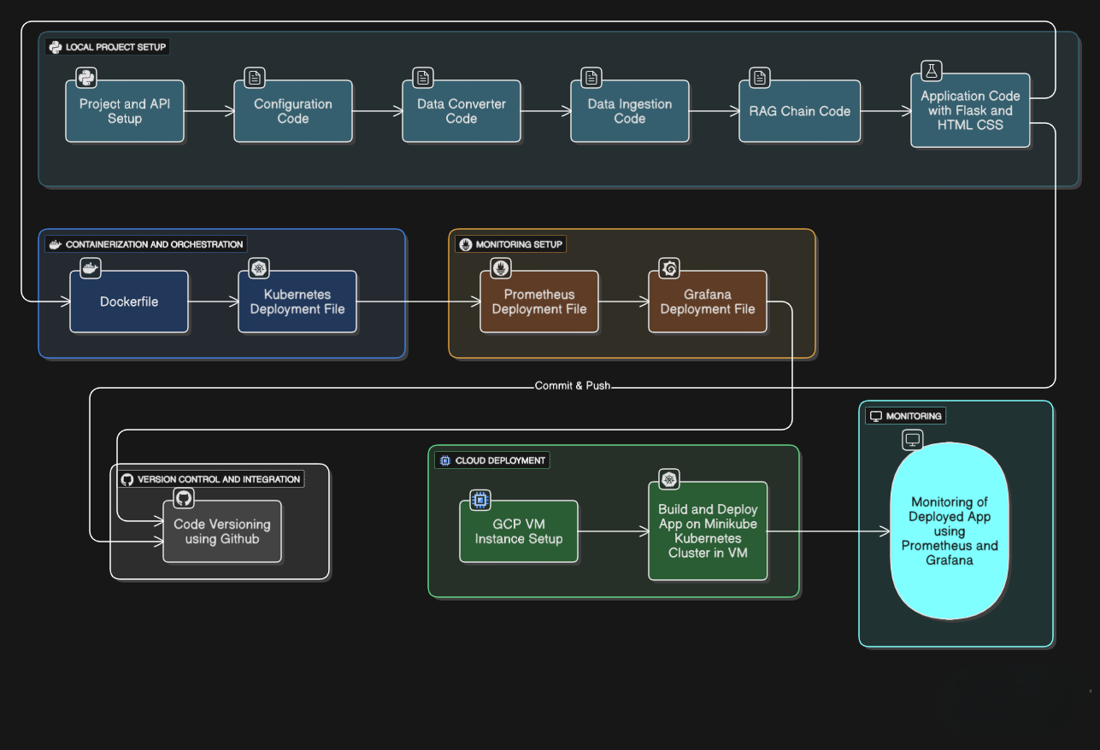

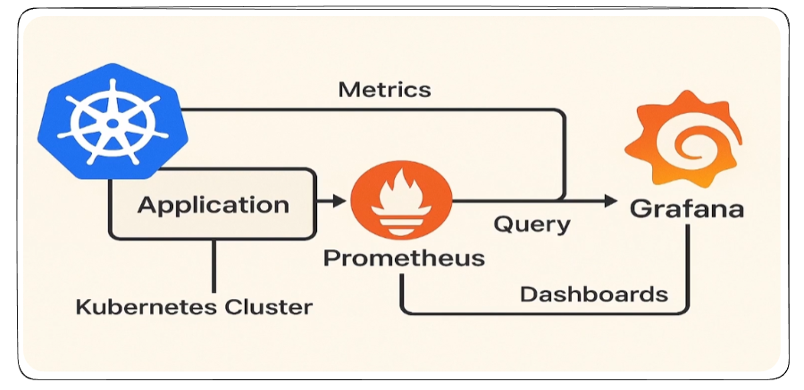

8. Key Modules
- Data ingestion and preprocessing
- Vector embedding generation
- Semantic search using AstraDB
- RAG agent development
- Context-aware conversation handling
- API exposure and UI development
- Deployment and monitoring

9. Learning Outcomes
- Understanding RAG systems
- Working with vector databases
- Building agentic AI systems
- Full-stack AI deployment

10. Resource Links
- LangChain: https://docs.langchain.com
- Groq: https://groq.com
- AstraDB: https://docs.datastax.com
- HuggingFace: https://huggingface.co
- Langchain video : https://www.youtube.com/watch?v=vzJOAnwIokM

